COMMON COURSE ASSIGNMENT FORMATAgnes Shifan

A. Assignment Information
Particular | Details
Department | Computer Science Engineering
Programme | B.E. / B.Tech
Course Code & Course Name | CSA07 – Computer Networks
Academic Year / Batch | _____2 year___________
Faculty Name | ____Agnes Shifani.S____________
Assignment Title | Real-Time Energy Monitoring and Power Consumption Analysis
Date of Issue | ________________
Date of Submission | ________________
Maximum Marks | 100
Course Outcome(s) – CO | CO3, CO4, CO5, CO7, CO8
Bloom's Taxonomy Level | L4 – Analyze; L5 – Evaluate; L6 – Create
SDG Mapping | SDG 7 – Affordable and Clean Energy; SDG 9 – Industry, Innovation and Infrastructure; SDG 12 – Responsible Consumption and Production
Industry / Societal Relevance | Smart energy management, IoT monitoring, energy efficiency, load analysis, data communication and resource optimization.

B. Assignment Problem / Challenge
Industry context: Modern homes, educational institutions, offices and industries contain many electrical loads whose power consumption changes throughout the day. Conventional energy meters mainly provide cumulative readings and do not always provide convenient real-time visibility into individual loads or consumption patterns. A monitoring system is therefore required to collect electrical parameters continuously, transmit measurements, analyze consumption and present useful information.
Student challenge: Act as an engineering designer and develop, simulate or prototype a real-time energy monitoring system that measures electrical parameters, calculates power and energy, stores time-stamped readings and provides meaningful analysis through tables, graphs or a dashboard. Evaluate the system under different load conditions and discuss accuracy, responsiveness, communication performance and resource usage.

C. Problem Statement
Design and evaluate a real-time energy monitoring and power consumption analysis system for a selected environment such as a laboratory, classroom, hostel room, office or small residential setup. The system should acquire relevant electrical measurements such as voltage, current, power, power factor where applicable and cumulative energy.
The design should include measurement/acquisition, processing, communication or data transfer, storage and visualization/analysis stages. Test the system under different load conditions, compare measured values with a suitable reference where available, calculate measurement error, identify high-consumption periods and recommend methods for improving energy efficiency.

D. Requirements and Constraints
- Identify suitable electrical parameters and measurement intervals.
- Use logically separated measurement, processing, storage and visualization functions.
- Provide real-time or near-real-time transmission where communication is used.
- Calculate instantaneous power and cumulative energy using appropriate relationships.
- Store time-stamped readings for historical analysis.
- Test at least three load conditions: low, medium and high.
- Report voltage, current, power, energy and other supported parameters.
- Evaluate measurement error against a suitable reference instrument or known condition.
- Measure update/response time and communication performance where applicable.
- Demonstrate the effect of changing load conditions on power and cumulative energy.
- Use an approved modern tool such as Arduino/ESP32, Raspberry Pi, Python, MATLAB/Simulink, Node-RED or another platform.
- Consider electrical safety, data security/privacy, scalability, cost and efficient resource use.
- Clearly state assumptions where exact site/load data are unavailable.

E. Student Work

1. Problem Understanding and Formulation
- Identify stakeholders, users, monitored loads, electrical parameters and information requirements.
- List assumptions and convert the practical problem into measurable engineering requirements.
- Prepare a system/block diagram showing sensors, controller, communication, storage and dashboard.
- Identify possible measurement errors, communication failures, data-loss points and high-load conditions.

2. Application of Course Knowledge
- Apply computer networking, data communication and IoT concepts where relevant.
- Explain sensors, embedded processing, communication protocols and data storage.
- Apply TCP/UDP or application-layer concepts when network transmission is implemented.
- Explain real-time data transfer and why update delay matters.
- Apply mathematical relationships for power and energy calculation.
- Use suitable data-analysis and visualization techniques.

3. Solution / Design / Methodology
- Develop a baseline design and a second feasible alternative.
- Create the measurement, processing, communication, storage and visualization plan.
- Implement or configure the selected sensing and acquisition method.
- Collect measurements for low, medium and high load conditions.
- Calculate power and cumulative energy.
- Store time-stamped readings and generate tables/graphs.
- Introduce controlled load changes and record system response.
- Compare alternatives using measurable criteria and select the better design.

4. Use of Modern Tools
- Primary options: Arduino/ESP32 with suitable sensors, Python, MATLAB/Simulink, Node-RED or a web dashboard.
- Alternative options: Raspberry Pi, cloud/IoT platforms, spreadsheet tools or another approved platform.
- Submit screenshots, configuration evidence, source code where applicable and exported results/logs.

5. Results and Validation
- Provide system/block diagram and implementation evidence.
- Report voltage, current, power, energy and other parameters for each test case.
- Report measurement error using an appropriate formula.
- Compare low, medium and high load conditions.
- Report update/response time and communication performance where applicable.
- Validate that the system satisfies the stated requirements.

6. Analysis and Engineering Decision
- Compare Alternative A and Alternative B using common measurable criteria.
- Discuss accuracy, response time, communication reliability, storage, scalability, complexity and cost.
- Identify advantages, limitations and trade-offs.
- Recommend the final architecture using quantitative evidence.

7. Broader Considerations
- Discuss energy efficiency and responsible energy consumption.
- Discuss electrical safety and measurement isolation.
- Discuss basic data security and privacy.
- Comment on scalability to multiple rooms/buildings/loads.
- Consider dashboard accessibility and service quality.
- Discuss efficient use of computing, communication and storage resources.

8. Conclusion
- Summarize the final monitoring architecture and analysis method.
- State major measurement and performance findings.
- State whether requirements are met and identify limitations.
- Suggest practical improvements for production deployment.

9. Student Reflection
- What energy-monitoring or networking concept did you understand better?
- What unexpected measurement, communication or load behaviour did you observe?
- If additional time, tools or budget were available, what would you improve and why?

10. References
Use an appropriate citation format and acknowledge textbooks, standards, datasheets, software documentation, datasets, research papers and AI-assisted tools used.
- Forouzan, B. A., Data Communications and Networking.
- Tanenbaum, A. S. and Wetherall, D. J., Computer Networks.
- Kurose, J. F. and Ross, K. W., Computer Networking: A Top-Down Approach.
- Relevant IEC/electrical measurement standards and manufacturer datasheets.
- Official documentation for the selected controller, programming environment and visualization platform.

Expected Student Deliverables
- System/block or architecture diagram.
- Sensor and parameter selection table.
- Measurement and data-acquisition methodology.
- Implementation/circuit or simulation evidence.
- Source code/configuration where applicable.
- Test cases and raw/processed measurement data.
- Performance result tables and graphs.
- Comparison of two design alternatives.
- Final recommendation with engineering justification.
- Technical report with references and reflection.

Suggested Pseudo Code
START
Initialize processor, memory, sensors and communication interface
Set sampling interval
Initialize voltage, current, power and energy variables
Configure interrupt/DMA for sensor data acquisition
WHILE monitoring is active
Acquire voltage and current samples
Transfer sensor data to memory
Calculate instantaneous power = voltage × current
Update cumulative energy consumption
Store time-stamped measurement
Update real-time monitoring dashboard
IF power exceeds threshold
Generate energy alert
END IF
Measure CPU utilization, CPI, cache misses and data-transfer overhead
END WHILE
Generate power-consumption analysis report
Compare architectural alternatives
Recommend the architecture
END

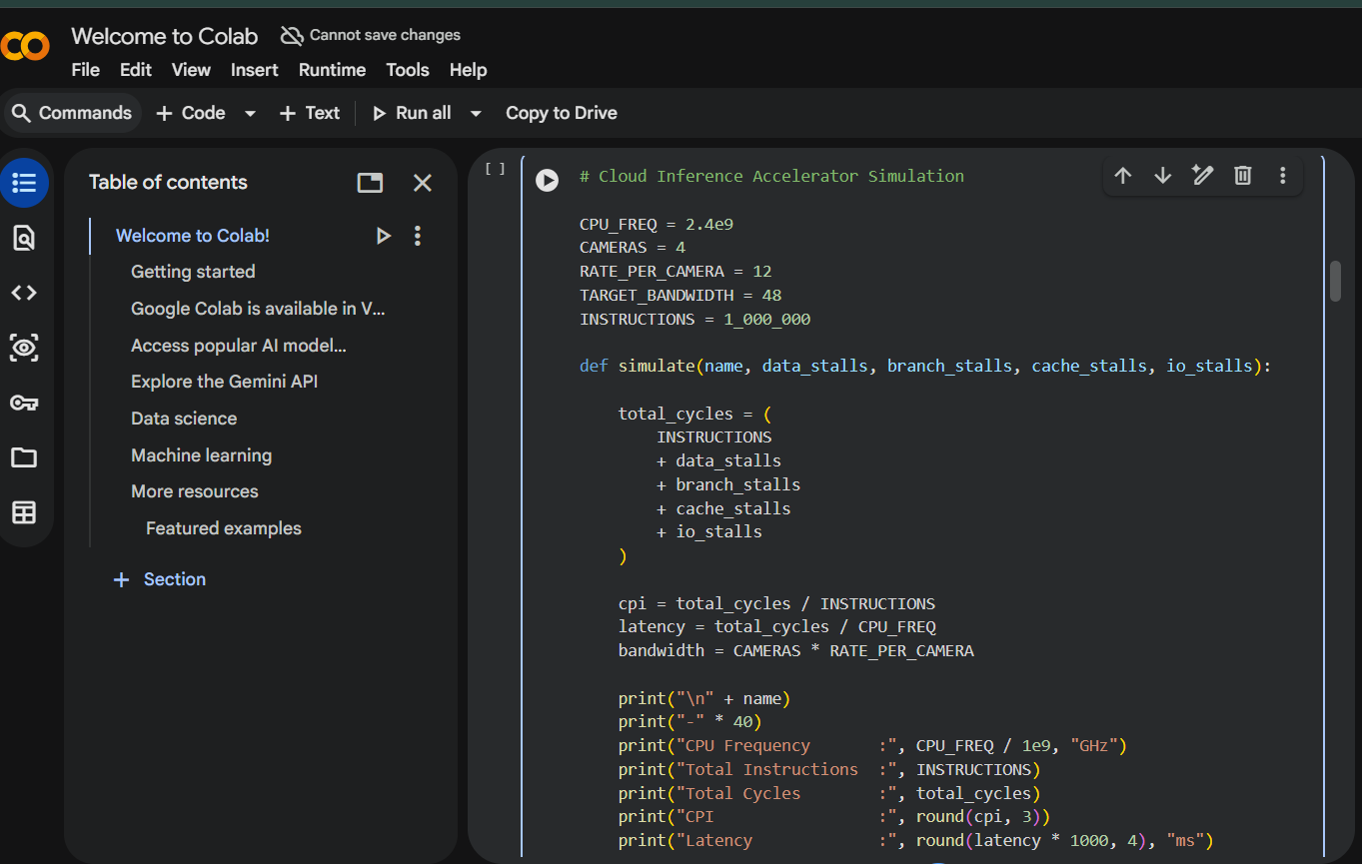
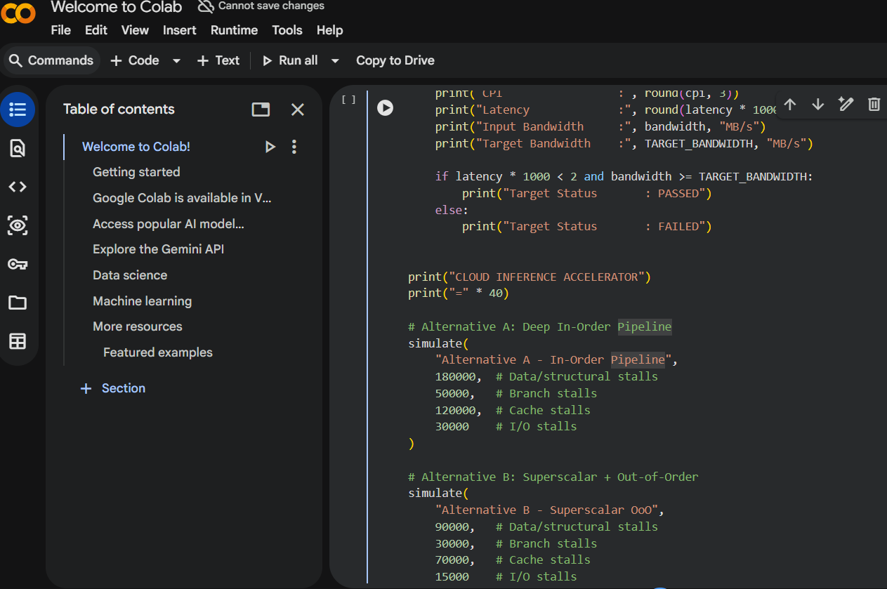
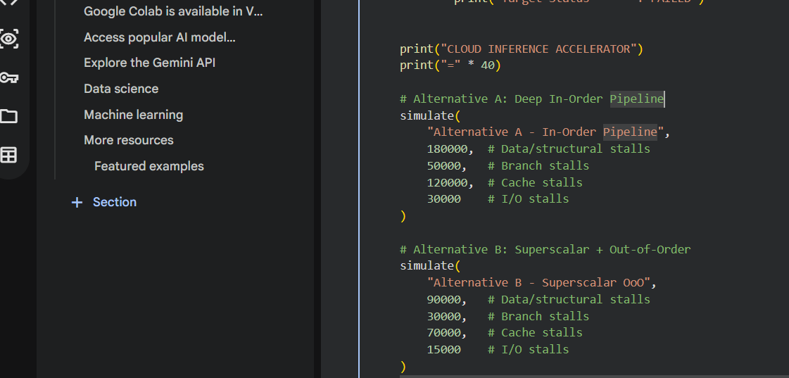

Output:
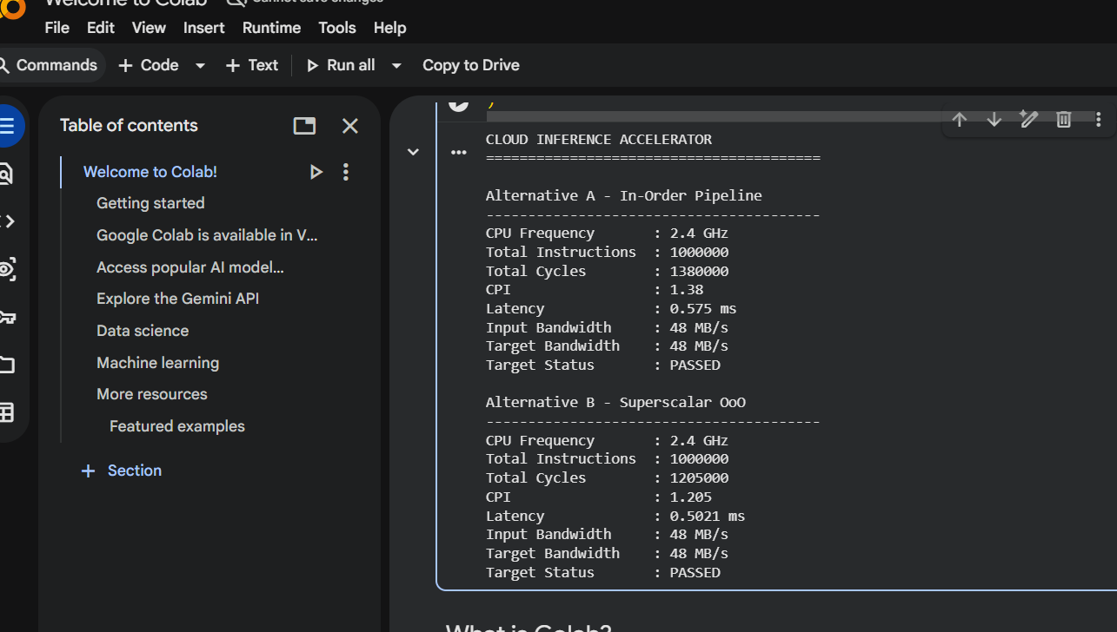

F. Common Assessment Rubric
Assessment Criterion | Marks | What is assessed
Problem understanding & formulation | 10 | Requirements, assumptions, problem definition and architecture
Application of course/domain knowledge | 20 | Measurement, networking, power-energy calculation and analysis
Solution methodology / design / implementation | 20 | Working design, implementation and test cases
Use of modern tools / techniques | 10 | Simulation/prototype tools and technical evidence
Results, testing & validation | 15 | Measurements, error analysis, tables/graphs and tests
Analysis, trade-offs & justification | 15 | Alternative comparison and engineering decision
Broader considerations / professional responsibility | 5 | Safety, security, scalability, sustainability
Technical documentation & reflection | 5 | Clear report, references and reflection
TOTAL | 100

G. CO–PO–Assessment Mapping
Assessment Component | CO | PO(s) | Bloom's Level | Marks
Problem formulation | CO3, CO8 | PO2, PO3 | L4 | 10
Application of knowledge | CO3, CO4, CO5 | PO1, PO2 | L3/L4 | 20
Solution / design / implementation | CO3, CO4, CO7 | PO3, PO5 | L4/L5/L6 | 20
Modern tool usage | CO7, CO8 | PO5 | L3/L4 | 10
Validation | CO4, CO7 | PO2, PO5 | L4/L5 | 15
Analysis & justification | CO7, CO8 | PO2, PO4 | L4/L5 | 15
Broader considerations | CO8 | PO6, PO7 | L4/L5 | 5
Documentation & reflection | CO6, CO8 | PO10 | L3/L4 | 5

H. Faculty Evaluation & Continuous Improvement CO Attainment
Performance Level | Criterion
Level 3 | ≥ 70%
Level 2 | 60–69%
Level 1 | 50–59%
Level 0 | < 50%
Target CO Attainment: ______________70%______
Actual CO Attainment: ___________75%_________

Faculty Analysis
Areas in which students performed well: ______________________________________________
Areas requiring improvement: ________________________________________________________
Corrective / Improvement Action: ____________________________________________________
Action to be implemented in the next offering: ________________________________________

Documents to be Maintained
- Assignment question/problem statement
- CO–PO and Bloom's mapping
- Assessment rubric
- Student submissions
- Tool/simulation/experimental evidence
- Evaluated scripts/reports
- Marks and rubric-wise assessment
- CO attainment analysis
- Sample student work representing different performance levels
Faculty analysis and continuous-improvement records shall be maintained as per departmental/course requirements.

